**Assignment 2: Advanced Power BI Analysis of Product Data**

1. **Introduction**

In this assignment, I analyse product data using Power BI. The goal is to apply advanced Power BI features such as calculated columns, measures, and visualizations to gain insights into the dataset. The dataset provided is [**products.csv**](https://docs.google.com/spreadsheets/d/1goWtJKUcRGTsCfnicwhr1DjjYiGoMF6lDJ5PfEk9Ppk/edit?gid=1035830595#gid=1035830595), which contains information about different products, including their price, cost, and other relevant details.

1. **Dataset Overview**

The dataset consists of the following key columns:

* **ProductKey** 🡪 A unique identifier for each product.
* **ProductSubcategoryKey** 🡪 A reference key linking the product to a subcategory.
* **ProductSKU** 🡪 Stock Keeping Unit (SKU), a unique code for tracking inventory.
* **ProductName** 🡪 The name of the product.
* **ModelName** 🡪 The model name of the product.
* **ProductDescription 🡪** A detailed description of the product.
* **ProductColor** 🡪 The color variant of the product.
* **ProductSize**  🡪 The size specification of the product (e.g., S, M, L, XL or numerical size).
* **ProductStyle** 🡪 The style category of the product (e.g., 0, M, U, W).
* **ProductCost** 🡪 The cost of the product for the company (manufacturing or procurement cost).
* **ProductPrice** 🡪 The selling price of the product.

1. **Methodology**

Importing the Dataset

* Open Power BI Desktop.
* Click on Get Data → CSV → Select products.csv.
* Load the dataset into Power BI.

1. **Tasks (1):**

Create a custom column that calculates the profit margin for each product. Use the formula: ProfitMargin = (ProductPrice - ProductCost) / ProductPrice. Name this column "ProfitMargin". Add a conditional column to classify products as "High Margin", "Medium Margin", or "Low Margin" based on their profit margin. Define the thresholds: High Margin (> 0.5), Medium Margin (0.2 - 0.5), Low Margin (< 0.2).

**Explication: (1)**

1. To calculate the profit margin, I clicked on add column then clicked on custom column.
2. change the name of custom column as a ProfitMargin and from the formula box insert productprice then use subtraction symbol then after ProductCost And close parentheses then divided by ProductPrice.

**= (ProductPrice - ProductCost) / ProductPrice.** Now we have ProfitMargin Column.

1. I used a Conditional Column to classify products
2. If ProfitMargin is Less than 0.2 then Low Margin (Output)
3. Clicked on Add Clause Else If ProfitMargin is Less than equal to 0.5 Medium Margin (Output)
4. In the bottom column Else I put High Margin (It is taken automatically, there is no need to enter the value.) Those values are greater than 0.5 are High Margin.

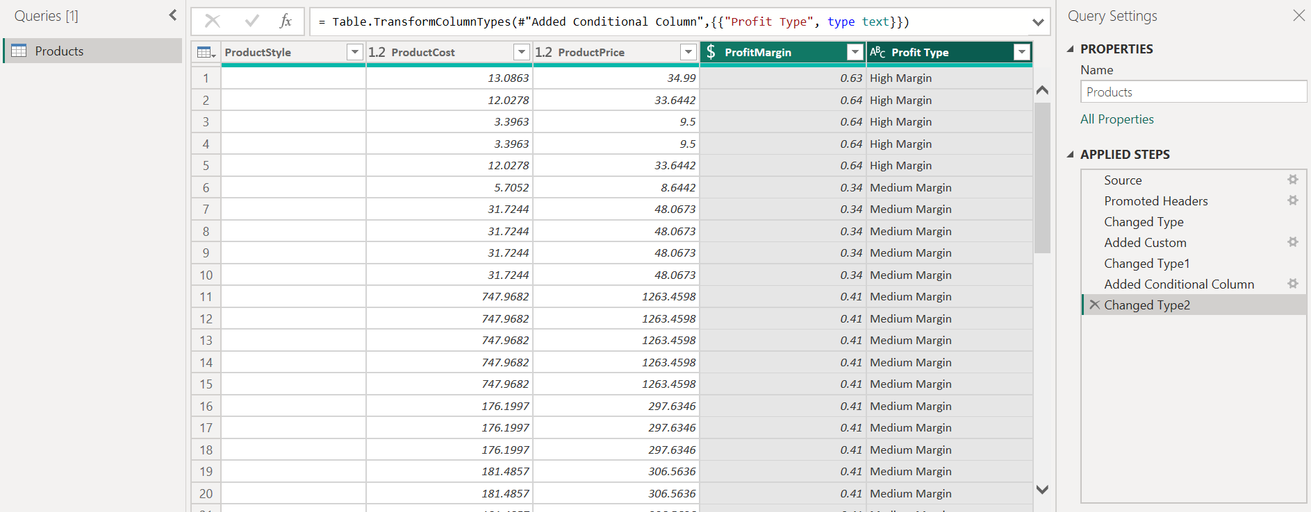

**Task (2):**

Use the Q&A feature to find out "What is the average product cost by product color?" and display the results as a bar chart.

**Explication: (2)**

1. In Report View. go to the Visualizations pane.
2. Click on the Q&A icon.
3. In the Q&A box, type What is the average product cost by product color?
4. Then Power BI generated automaticallyvisualization based on our data.

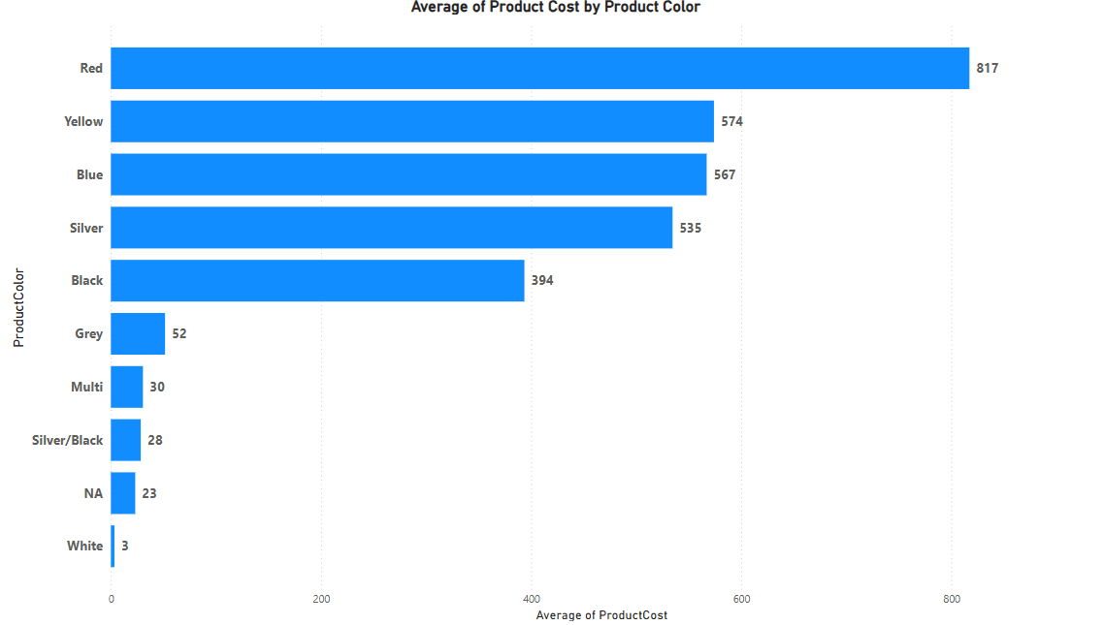

**Task (3):**

Create a decomposition tree to analyze ProductPrice by ProductColor and further by ProductStyle. Identify key drivers for high prices.

**Explication: (3)**

1. In Report View, go to the Visualizations pane.
2. Click on the Decomposition Tree icon.
3. In the Fields pane, drag ProductPrice into the Analyze field. This sets ProductPrice as the metric to analyze.
4. Drag ProductColor into the Explain by field. after that, the + symbol on the graph (Choose how to split your data) I selected High value.
5. This breaks down the prices by product color by high value.
6. Drag ProductStyle into the Explain by field below ProductColor. the + symbol on the graph (Choose how to split your data) I selected High value.
7. Our decomposition Tree will dynamically analyze and visualize key drivers of high product prices.

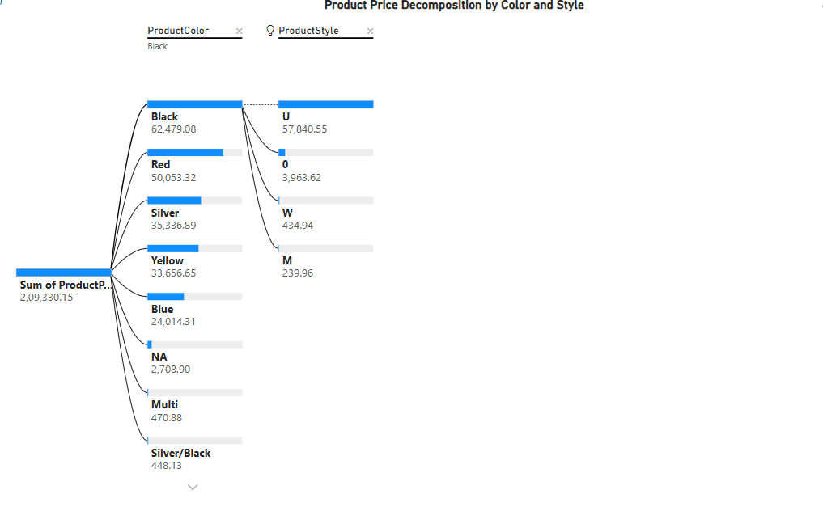

**Task (4):**

Use the Key Influencer visual to determine which factors (e.g., ProductColor, ProductSize, ProductStyle) influence high product prices. Provide a summary of your findings.

**Explication: (4)**

1. Click on view 🡪 select Key Influencer
2. Drag ProductPrice into the Analyze field (this is the target variable).
3. Drag ProductColor, ProductSize, ProductStyle, and any other relevant factors into the Explain By field.
4. Then Power BI will analyze the data and show which factors most influence high product prices. The Screenshot are below.

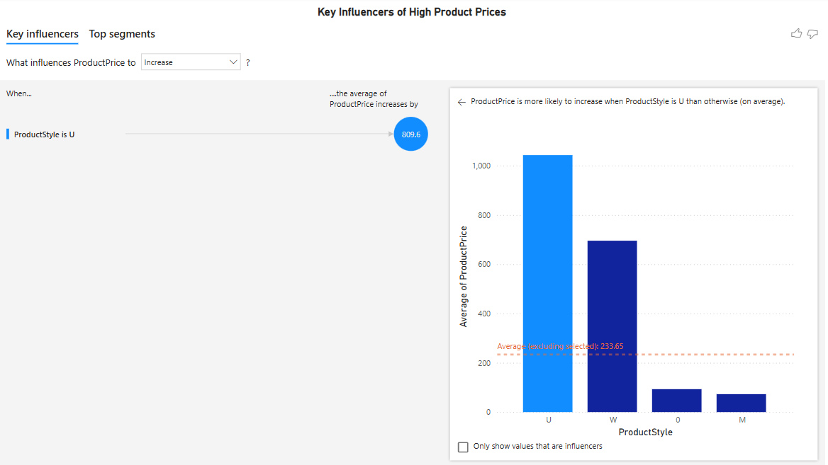

1. The factor that most increases ProductPrice is when ProductStyle is "U".
2. This means that products with style "U" tend to have significantly higher prices compared to other styles.
3. When ProductStyle is "U", the average price increases by **809.6** compared to other styles.

**Task (5):**

Create a new column using the "Column from Example" feature to extract the first letter from the product color column (eg: red should be R, etc). Create a table visual to display the total product cost by product color. Highlight the costs column using conditional formatting (highest costs in dark pink, medium costs in light pink and lowest costs in white).

**Explication: (5)**

1. In the Power Query Editor Click on Transform Data in the Home tab.
2. Select the ProductColor column.
3. Click on Add Column → Column from Examples → From Selection.
4. In the new column, type the first letter of each color as an example: For "Red", type R, For "Black", type B.
5. Power BI will automatically detect the pattern and fill in the rest.
6. Rename the new column to ProductColorInitial and click OK.
7. Click **Close & Apply** to save the changes and return to the report view.
8. Click on Table from the Visualizations pane.
9. Added the following fields to the table: ProductColor , ProductColorInitial and Product Cost (Productcolor is optional).
10. Clicked on the Format pane 🡪 Scroll down to **Cell Elements** after clicking.
11. Select sum of the Producost From series 🡪 On Background color 🡪 click on conditional Formatting. For Lowest value selected white color , then click on add middle color selected Light Pink color and for Highest value selected Dark Pink colour.
12. Then table displaying Total Product Cost by Product Color. A color-coded cost column where the highest costs appear in dark pink, medium costs in light pink, and the lowest in white for easy analysis.

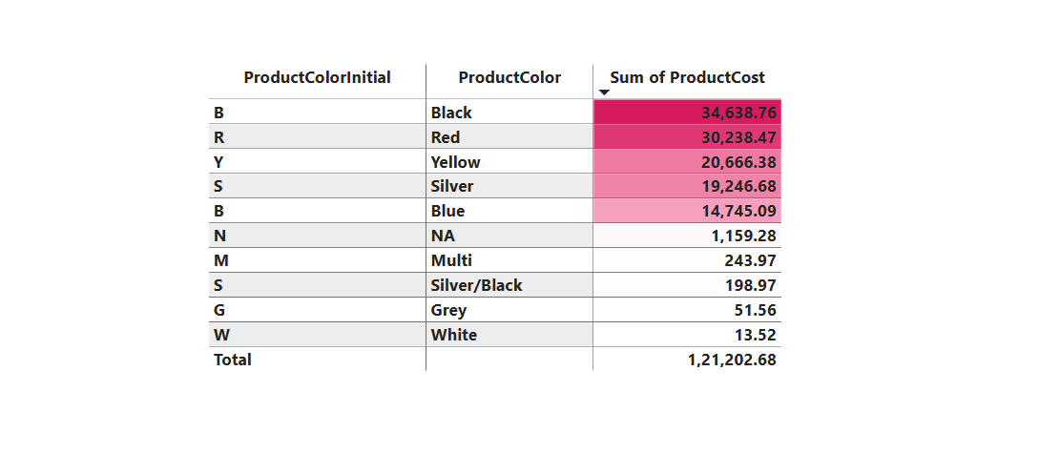

**Task (6):**

Set up bookmarks to save different views of your report. Create bookmarks for views by ProductStyle, ProductColor, and ProductSize based on your own set conditions or filters.

**Explication: (6)**

1. In Report view selected three charts from visualization like clustered bar chart, donut chart and treemap.
2. Clustered bar chart for Productstyle. Then dragged productStyle for X-axis, Y-axis for ProductPrice. For better clarity, added data levels.
3. Donut Chart for ProductColor. Then dragged productPrice to Values section and Productcolor to Legend section.
4. Treemap for productSize then dragged ProductSize to category column and ProductPrice to value column.
5. After added three slicers from visualization table for ProductStyle, productColor and ProductSize.
6. Then clicked on insert then added three buttons **apply all slicers, clear all slicers** and **Bookmark** in report canvas.

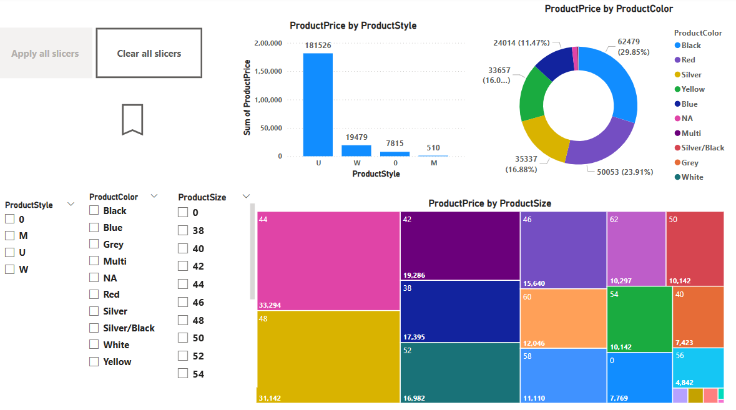

1. To activate the bookmark, choose **M** from the **ProductStyle** slicer, **Black** and **Blue** from the **ProductColor** slicer, and **L, M, S, and XL** from the **ProductSize** slicer.
2. Then, click on **View** → select **Bookmarks** from the **Pane Manager**, then click on **Add** and rename the bookmark as **Product Style Color Size**.
3. In **Report Canvas**, select the **Bookmark** button, then click on the **Format Pane**. Next, select **Action** and assign the bookmark.

**Task (7):**

Create a single row card to display the total number of unique products in the dataset. Create a multi-row card to display the total product cost, total product price, and average profit margin.

**Explication: (7)**

1. Go to the Report View. Click on Card from the Visualizations pane.
2. Drag and drop the ProductKey into the Fields section.
3. For multi-row card. Click on multi-row card from the Visualization pane.
4. Drag and drop the Product Cost, Product Price and Profit Margin into the field section.
5. Product Cost (Sum of Product Cost) change from field section.
6. Product Price (Sum of Product Price) change from field section.
7. Profit Margin (Average of profit margin) change from field section.

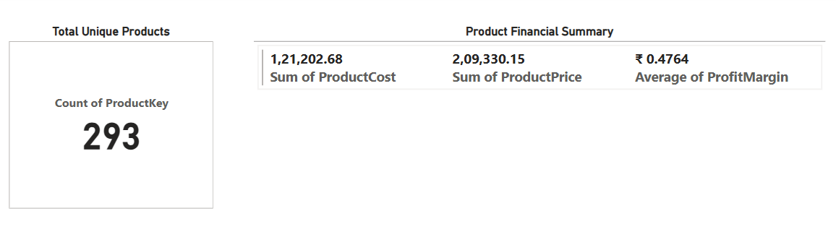

**Task (8):**

Add a reference line in a line chart to show the average product price over different product styles.

**Explication: (8)**

1. Go to Report View in Power BI. Click on Line Chart from the Visualizations pane.
2. Drag Product Style into the X-axis field.
3. Drag Product Price into the Y-axis field and set its aggregation to Average.
4. Go to the Format Pane then click on the reference line 🡪 Add line 🡪 Rename line.
5. In the type section select Averege line.
6. Customized the line style, color, and transparency as needed.
7. Now, our line chart displays the average product price as a reference line across different product styles.

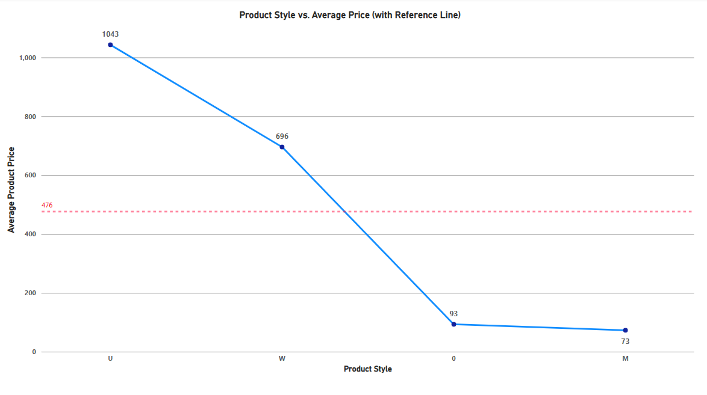

**Task (9):**

Identify and remove any duplicate product records in the dataset.

**Explication: (9)**

1. Click on Transform Data in Power BI. Select the Products table.
2. Then click on one column and press CTRL+a.
3. Then click on Home 🡪 Remove Rows 🡪 click on Remove Duplicates.

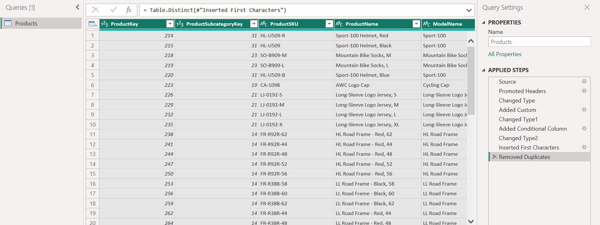

**Task (10):**

Create a Treemap to show product price for each color and subcategory. Also show

the top 3 subcategories based on profit (price-cost).

**Explication: (10)**

1. Go to the Report View. In the Visualizations pane, click on the Treemap visual.
2. Drag ProductColor to Category, Subcategory to Details and ProductPrice to Values.
3. Used Data Labels to display values inside the treemap.

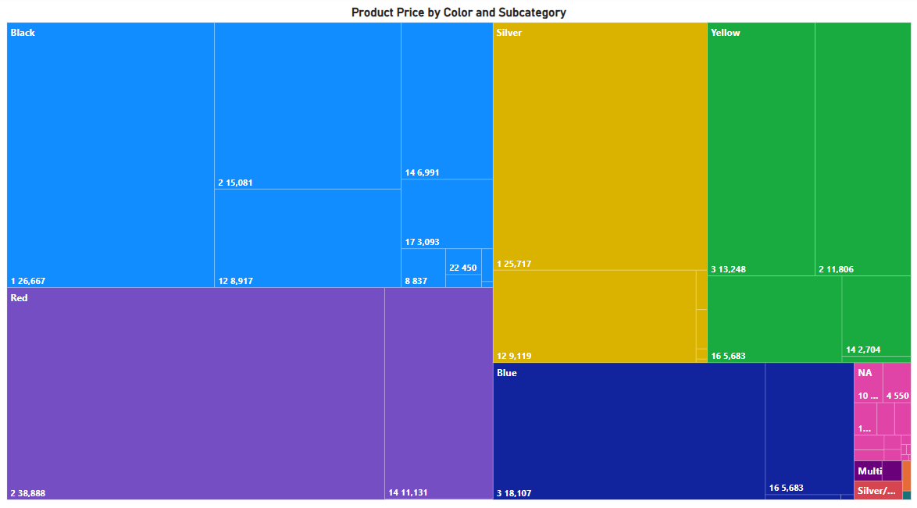

1. Selected Clustered Bar Chart from the Visualizations pane.
2. Drag Product Subcategory Key to Y-axis and Profit Margin column to X-axis.
3. Click on filter Pane 🡪 Top N 🡪 show items 🡪 3
4. Drag profit margin column to value and click on apply filter.
5. Now we have top 3 subcategories by profit margin.

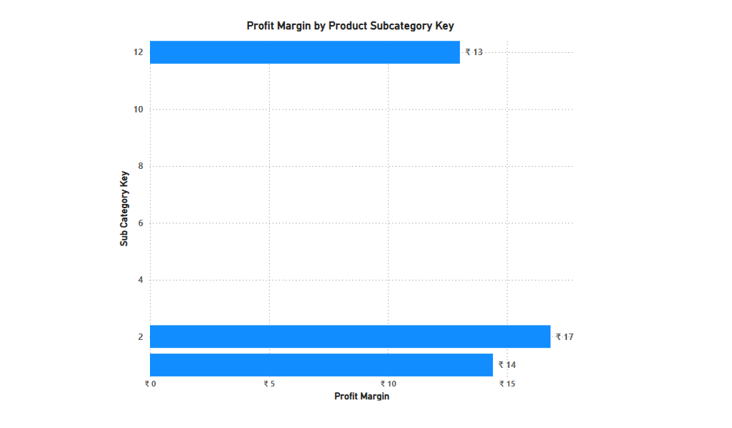

**Assignment completed by Ravi Kant**